**GRADED PROJECT 3 SCREENSHOTS.**

* Screenshot showing the Welcome page of the project.

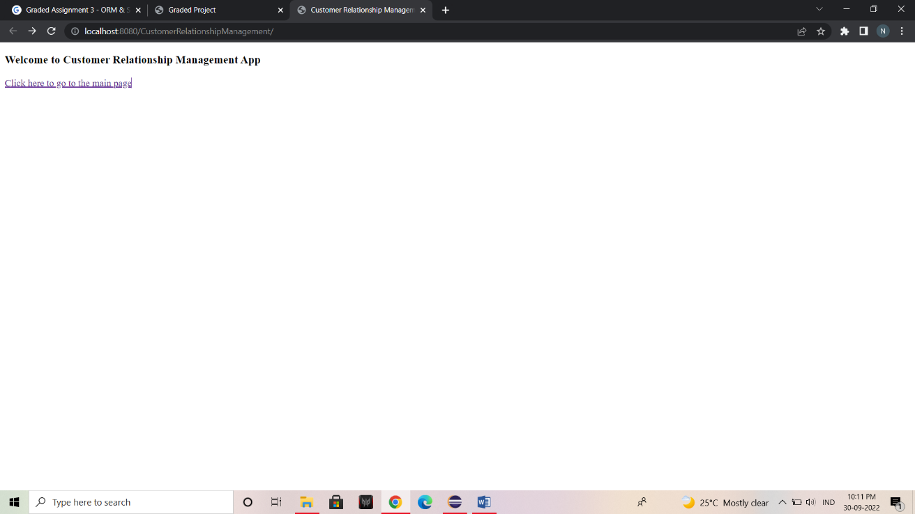

* Screenshot Showing the Main Page of the Project.

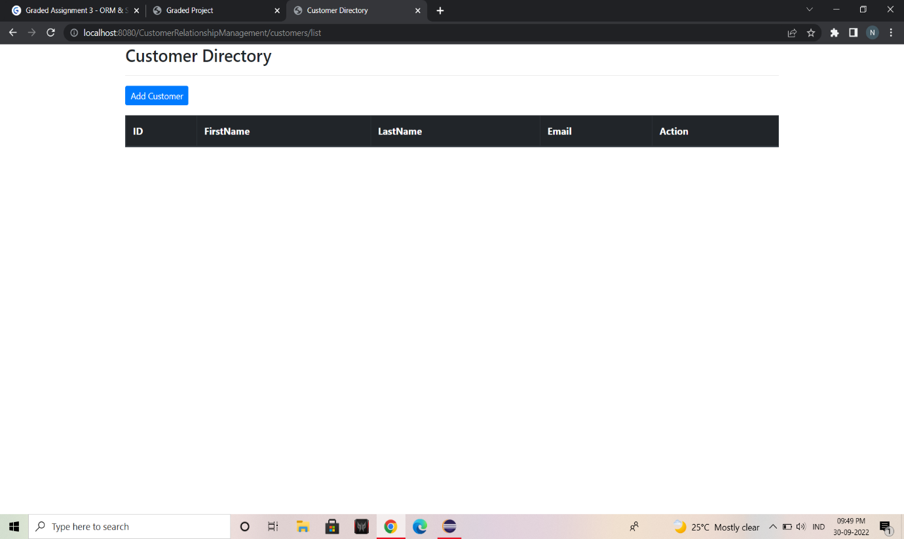

* Screenshot Showing the Add Form of the project.

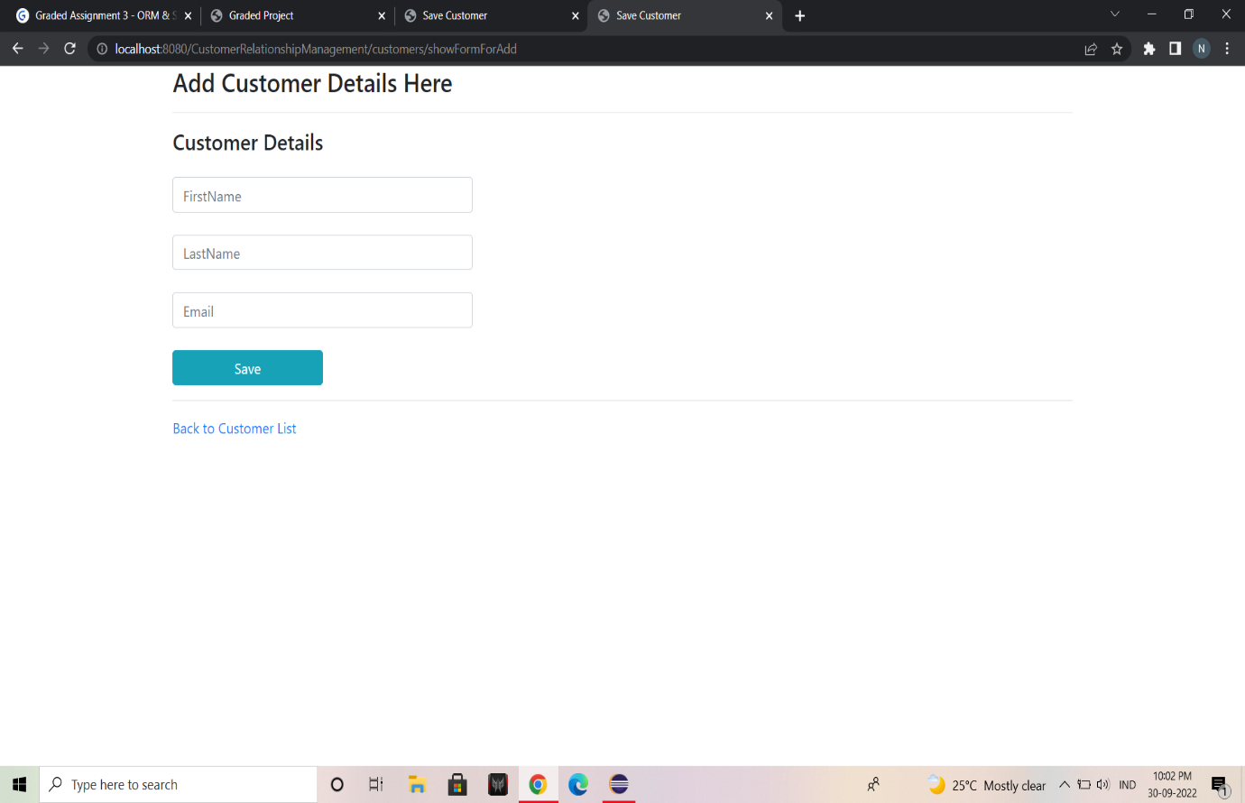

* Screenshot showing the Main page after adding customers to the list.

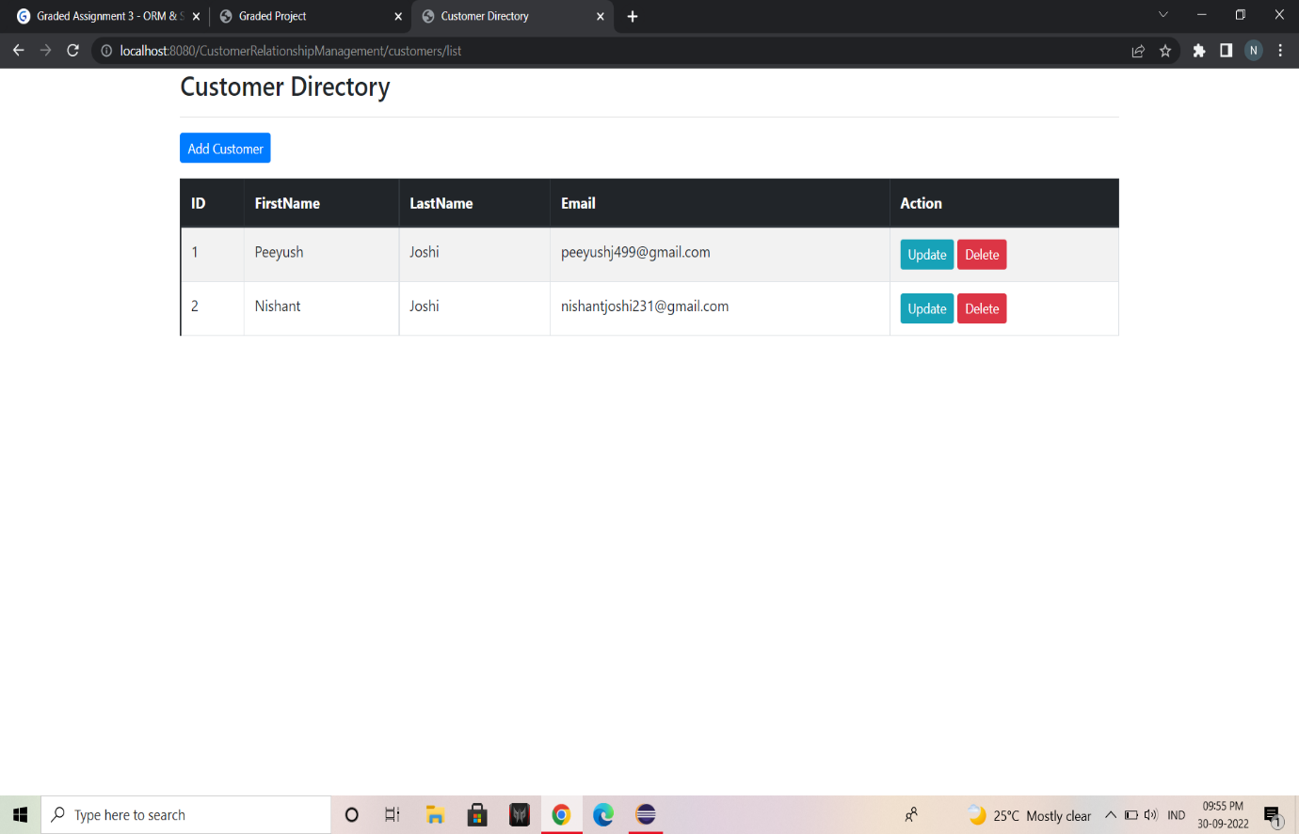

* Screenshot showing the main page after updating customers details.

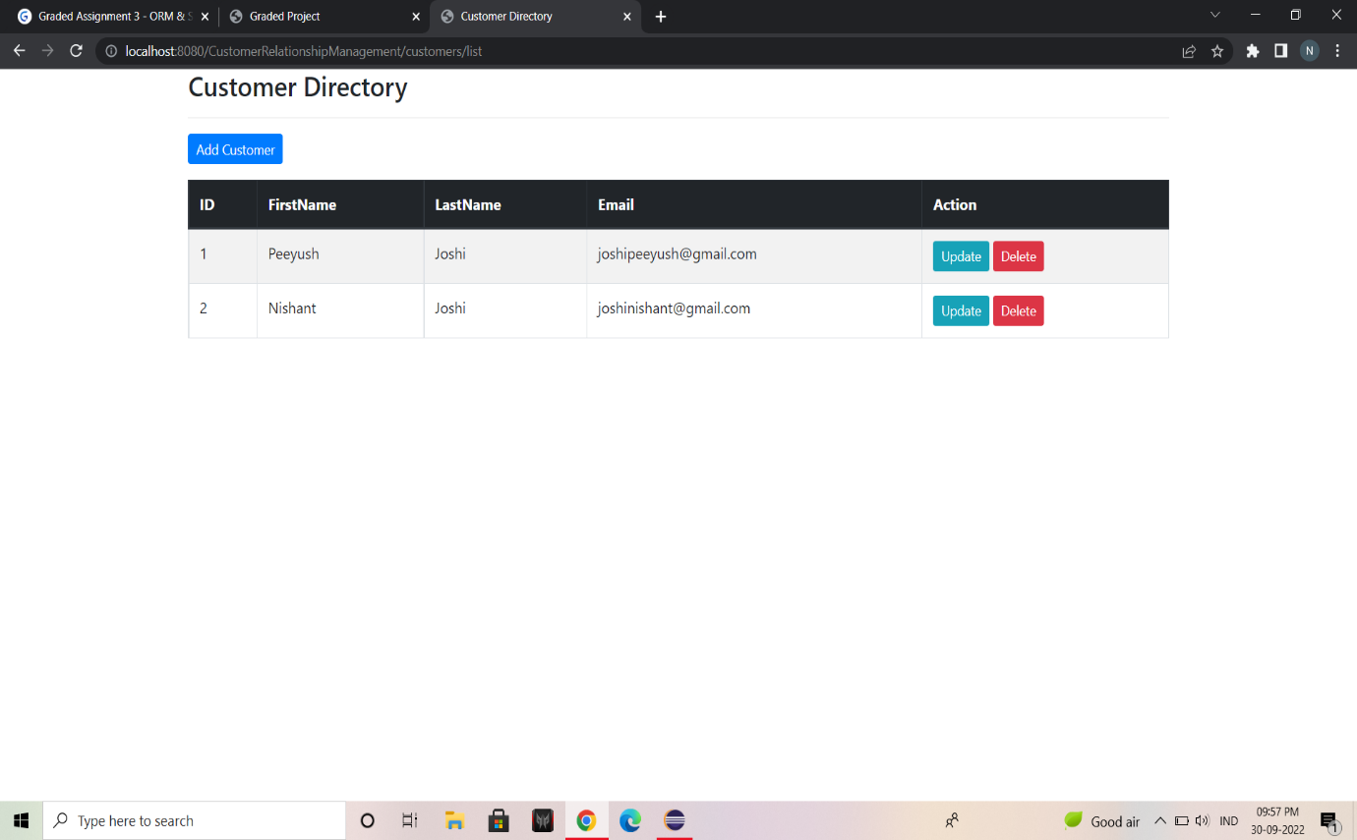

* Screenshot showing the main page after deleting a record.

